**IMSE 982 Final Project**

**Blake Conrad**

Problem 1: Quasi-convex function: Hyper-bowl; $f:R^{3}→R$

$$f(x,y,z)=\left(x^{2}+y^{2}+x∙y\right)+\left(y^{2}+z^{2}+y∙z\right)+\left(x^{2}+z^{2}+x∙z\right)$$

$$∇f\left(x,y,z\right)=\begin{matrix}4x+y+z \\ 4y+x+z \\ 4z+x+y\end{matrix}$$

$$H\left(x,y,z\right)=\begin{matrix}4 & 1 & 1 \\ 1 & 4 & 1 \\ 1 & 1 & 4\end{matrix}$$

*If we held z as a constant, we can try to visualize what this function looks like in the images below:*

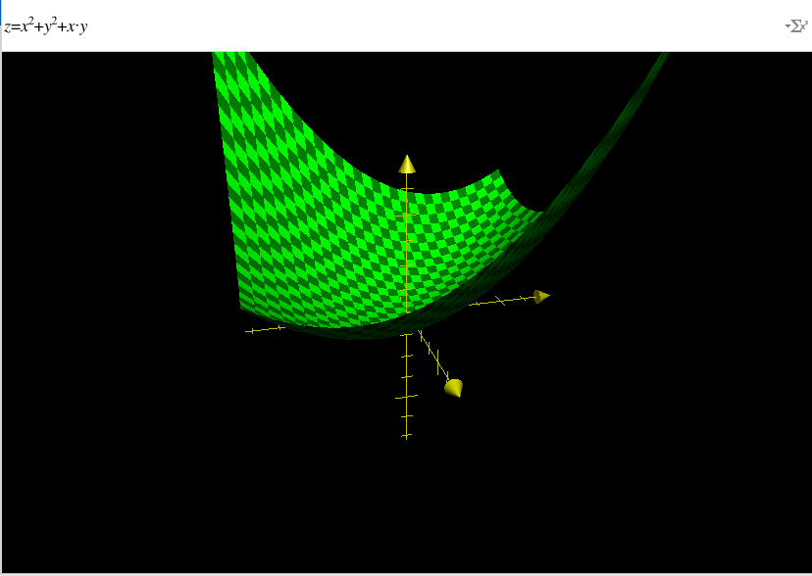

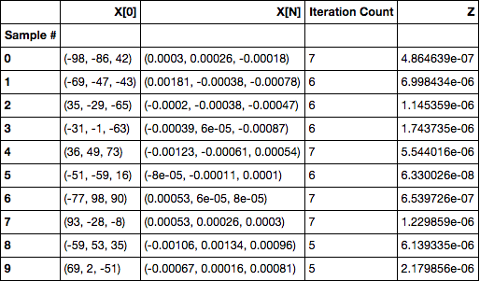

The z values are beyond the billionths place (5 0’s), hence these are sufficiently close to one another illustrating a global optimal from our convex function f.

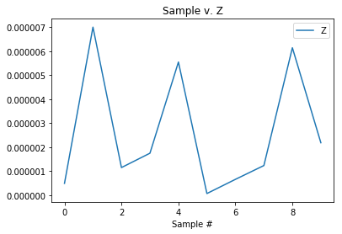

distance in millionths place

Problem 2: Multiple KKT function: Periodic Wave Function; $f:R^{3}→R$

$$f\left(x,y,z\right)=\sin\left(x\right)∙\cos\left(y\right)+\frac{y}{z}+\frac{x}{z}$$

$$∇f\left(x,y,z\right)=\begin{matrix}\cos\left(x\right)∙\cos\left(y\right)+\frac{1}{z} \\ -sin\left(y\right)∙\sin\left(x\right)+\frac{1}{z} \\ -\frac{x}{z^{2}}-\frac{y}{z^{2}}\end{matrix}$$

$$H\left(x,y,z\right)=\begin{matrix}-sin(x)∙cos⁡(y) & -sin⁡(y)∙cos⁡(x) & -\frac{1}{z^{2}} \\ -cos⁡(x)∙sin⁡(y) & -\cos\left(y\right)∙sin⁡(x) & -\frac{1}{z^{2}} \\ -\frac{1}{z^{2}} & -\frac{1}{z^{2}} & \frac{2x}{z^{3}}+\frac{2y}{z^{3}}\end{matrix}$$

Each dimension will reflect the underlying wave shape below:

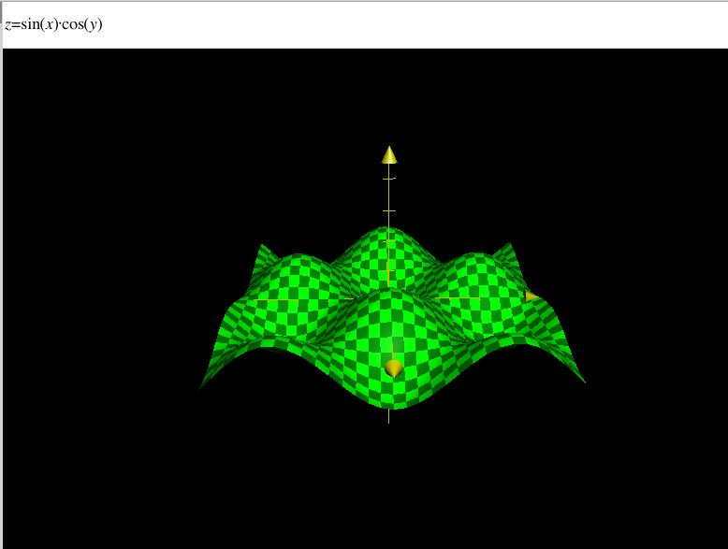

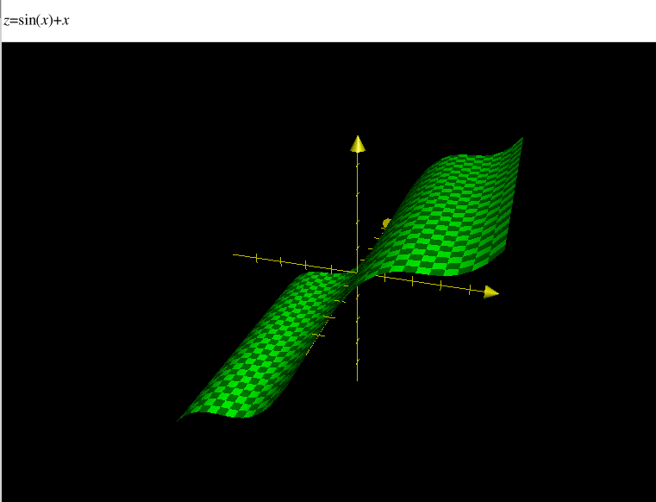

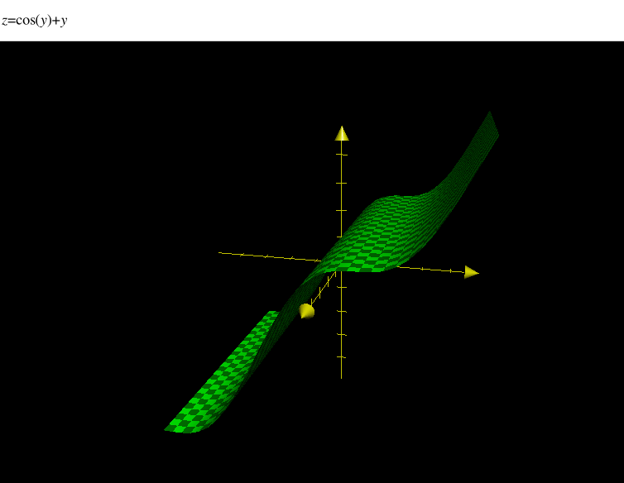

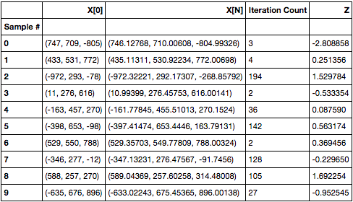

We see optimal solutions everywhere from -3 to 1 and in between. Hence, we are dealing with a multiple KKT points and have a sample of 10 different local minima on f.

